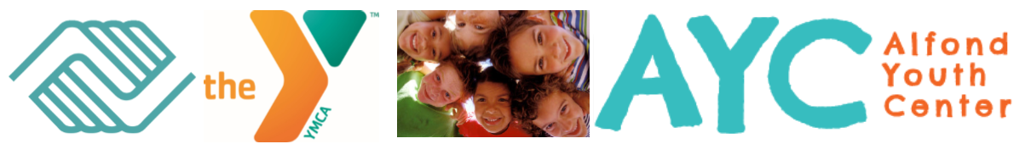

Dear Mentors:

My name is Karla Stratton and I am excited to hear that you may be interested in our Reach & Rise Group Mentoring program here at the Alfond Youth Center.

I have been working at the Alfond Youth Center for the past eight and a half years, I am currently the Reach & Rise Group Mentoring Director. The Group Mentoring Program is a unique program that is eight to sixteen weeks in length and is facilitated by two volunteer mentors and up to six students. The mentoring groups meet once a week for two hours at our facility here in Waterville, the plans for each mentoring group is supplied by us and previously created and ready to be completed.

The Reach & Rise**®** therapeutic mentoring program began as a 1:1 mentoring program at The YMCA of San Francisco in 1992 and has been a national program since 2009. The group mentoring program began in 2015. It was designed to serve youth in a group setting to provide a safe place for them to process thoughts and feelings that help normalize their experiences, challenges, and developmental milestones, and reduce isolation and gain healthy peer support. Though mentoring groups utilize a therapeutic model, they are not psychotherapy or counseling groups and mentors will only fulfill roles as volunteers, even if they work professionally as a trained counselor or mental health professionals. Mentoring groups are considered psychoeducational groups as they provide education, activities, and discussion about specific content or themes related to reasons mentees were referred and they help increase understanding, awareness, skill building, and making positive behavioral changes.

As a mentor you will go through an application, interview and screening process. You will also be provided with information to help you to be successful mentors and work with youth and families, learn about program expectations and determine if the required commitment fits your own expectations and schedule. You will learn new skills and techniques that will help you to feel more confident and less anxious about mentoring. Before you officially become a mentor you will receive fifteen hours of free training, this training provides an opportunity for mentors to learn about their biases and how that can impact a person’s ability to learn about a new culture or another person’s experiences.

I appreciate your taking the time to read about our program and should you have any questions or think that this volunteer program could be a great fit for you I would love to hear from you.

Sincerely,

Karla Stratton

After School Program Coordinator

Reach & Rise® Group Mentoring Director

(207)872-7759

kstratton@alfondyouthcenter.org

**Boys & Girls Clubs and YMCA of Greater Waterville at the**

**ALFOND YOUTH CENTER**

# **Board Members**

Brent Burger

*Chair*

Dr. Margaret Griffin

*1st Vice Chair*

Scott Jones

*2nd Vice Chair*

Jane Bickford

*Secretary*

Mike Runser

*Treasurer*

Kenneth A. Walsh

*CEO*

Michaela Murphy

*Past Chair*

Dr. Steve Diaz

Dan Dubord

Carolyn Greene

Ray Haskell

Sue Hawkes

Jim Hughes

Joe Jabar, Jr.

Brian Kelly

Maeghan Maloney

Phil Roy

Dan Shea

Ken Walsh

# **Founders Club Officers**

Jerry Tipper

*President*

Dr. Barbara Woodlee

*Vice President*

Brian Bernatchez

*2nd Vice President*

Germaine Orloff

*Secretary*

126 North Street * Waterville, ME 04901 * 207.873.0684 * Fax 207.861.8016 * www.clubayc.org