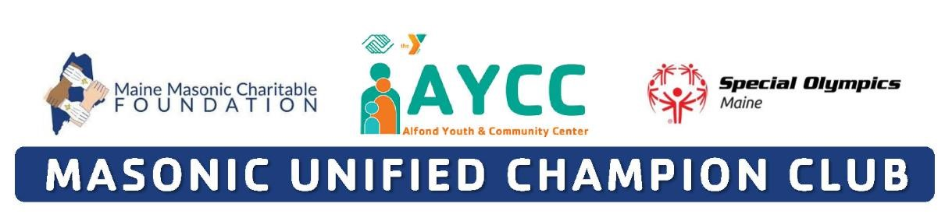
I agree to the following:
- Ability to Participate. I am physically able to take part in Unified Club activities.
- Likeness Release. I give permission to the Alfond Youth & Community Center (AYCC), Special Olympics and the Maine Masonic Foundation to use my likeness, photo, video, name, voice, words, and biographical information to promote Unified Club Programs, raise funds for the AYCC Unified Club, and acknowledge partners’ and sponsors’ support for the AYCC Unified Club.
- Risk of Concussion and Other Injury. I know there is a risk of injury. I understand the risk of continuing to participate with or after a concussion or other injury. I may have to get medical care if I have a suspected concussion or other injury. I also may have to wait 7 days or more and get permission from a doctor before I start playing sports again.
- Emergency Care. If I am unable, or my guardian is unavailable, to consent or make medical decisions in an emergency, I authorize the AYCC to seek medical care on my behalf.
- Health Programs. If I take part in a health program as a participant, I consent to health activities, screenings, and treatment. This should not replace regular health care. I can say no to treatment or anything else at any time.
- Personal Information. I understand that the AYCC will be collecting my personal information as part of my participation, including my name, image, address, telephone number, health information, and other personally identifying and health related information I provide to the AYCC (“personal information”).
  - I agree and consent to the AYCC: o using my personal information in order to: make sure I am eligible and can participate safely; run trainings and events; share competition results (including on the Web and in news media); provide health treatment if I participate in a health program; analyze data for the purposes of improving programming and identifying and responding to the needs of Unified Club participants; perform computer operations, quality assurance, testing, and other related activities; and provide event-related services.
  - using my personal information for communications and marketing purposes, including direct digital marketing through email, text message, and social media.
  - sharing my personal information with (i) researchers, such as universities and public health agencies, that are studying intellectual disabilities and the impact of Unified Club activities, (ii) medical professionals in an emergency, and (iii) government authorities for the purpose of assisting me with any visas required for international travel to Unified Club events and for any other purpose necessary to protect public safety, respond to government requests, and report information as required by law.
  - I have the right to ask to see my personal information or to be informed about the personal information that is processed about me. I have the right to ask to correct and delete my personal information, and to restrict the processing of my personal information if it is inconsistent with this consent.
  - Privacy Policy. Personal information may be used and shared consistent with this form.

- Background Check Authorization. [APPLIES TO ADULTS ONLY] I authorize the AYCC to conduct a background check on me. This background check may be done through a third party. The background check may include an inquiry into my employment, education, driving, and/or criminal history. I understand that the AYCC may rely on information provided or discovered to determine whether I may participate in Unified Club activities. By signing below, I authorize investigators to conduct a background check as described in this form. I further authorize any third parties or agencies who may be in possession of the requested information, to disclose such information in connection with this background check.

- Waiver and Liability Release. I understand the risks involved with participation in Unified Club activities. I fully accept and assume all such risks and all responsibility for losses, costs, and damages I may incur as a result of my participation. I hereby release and agree not to sue any AYCC organization, its directors, agents, volunteers, and employees, and other participants (“Releases”) related to any liabilities, claims, or losses on my account caused or alleged to be caused in whole or in part by the Releases. I further agree that if, despite this release, I, or anyone on my behalf, makes a claim against any of the Releases, I will indemnify and hold harmless each of the Releases from any such liabilities, claims, or losses as the result of such claim. I agree that if any part of this form is held to be invalid, the other parts shall continue in full force and effect.

Name:
VOLUNTEER / UNIFIED PARTNER SIGNATURE (required for adult with capacity to sign legal documents)
I have read and understand this form. If I have questions, I will ask. By signing, I agree to this form.
Volunteer/Unified Partner Signature: | Date:
PARENT / GUARDIAN SIGNATURE (required for participant who is a minor or lacks capacity to sign legal documents)
I am a parent or guardian of the participant. I have read and understand this form and have explained the contents to the participant as appropriate. By signing, I agree to this form on my own behalf and on behalf of the participant.
Parent / Guardian Signature: | Date:
Printed Name: | Relationship:

Please submit completed Athlete Registration forms (original) to Alexander Carey via email, fax, or mail:

Email – acarey@clubaycc.org
Fax – 1-207-861-8016
Mail – AYCC, 126 North Street, Waterville, ME 04901 attn: Alex Carey

